*Yes! I want to become a member of the IPA!*

Membership in the International Phalaenopsis Alliance includes the

*Phalaenopsis Journal*, a quarterly digital magazine, and PHALS Digest, an online email subscription.

(Please Print Clearly)

Name: ____________________________________________________________

Company: ________________________________________________________

Address: __________________________________________________________

Address: __________________________________________________________

City: __________________________ State/Province: ______________________

Zip/Postal Code: ______________ Country: ________________________________

Telephone: (Home) _____________________ (Work) ________________________

Email: ____________________________________________________________

**Membership includes an Electronic Journal only distributed through Joomag:**

  1 Year (4 Issues) $40 (U.S. Dollars)   2 Year (8 Issues) $76 (U.S. Dollars)

**IPA Contribution**:   $10       $25      $50      Other $________

The IPA is recognized as a nonprofit organization under Section 501(C)(3) of the Internal Revenue Code.

All contributions to the IPA are tax-deductible.

Total Amount $___________ Method of payment:  MasterCard  Visa

 Check or money order (U.S. funds drawn on a U.S. bank only)

Card number: ---   
Expiration date:  / Verification Code:  

Name as it appears on card: ________________________________________

Signature ___________________________________________________

Type of growing (check all that apply):

 Greenhouse  Windowsill  Under lights  Beginner  Intermediate  Advanced  Hobby  Commercial  Society  Other: __________________________

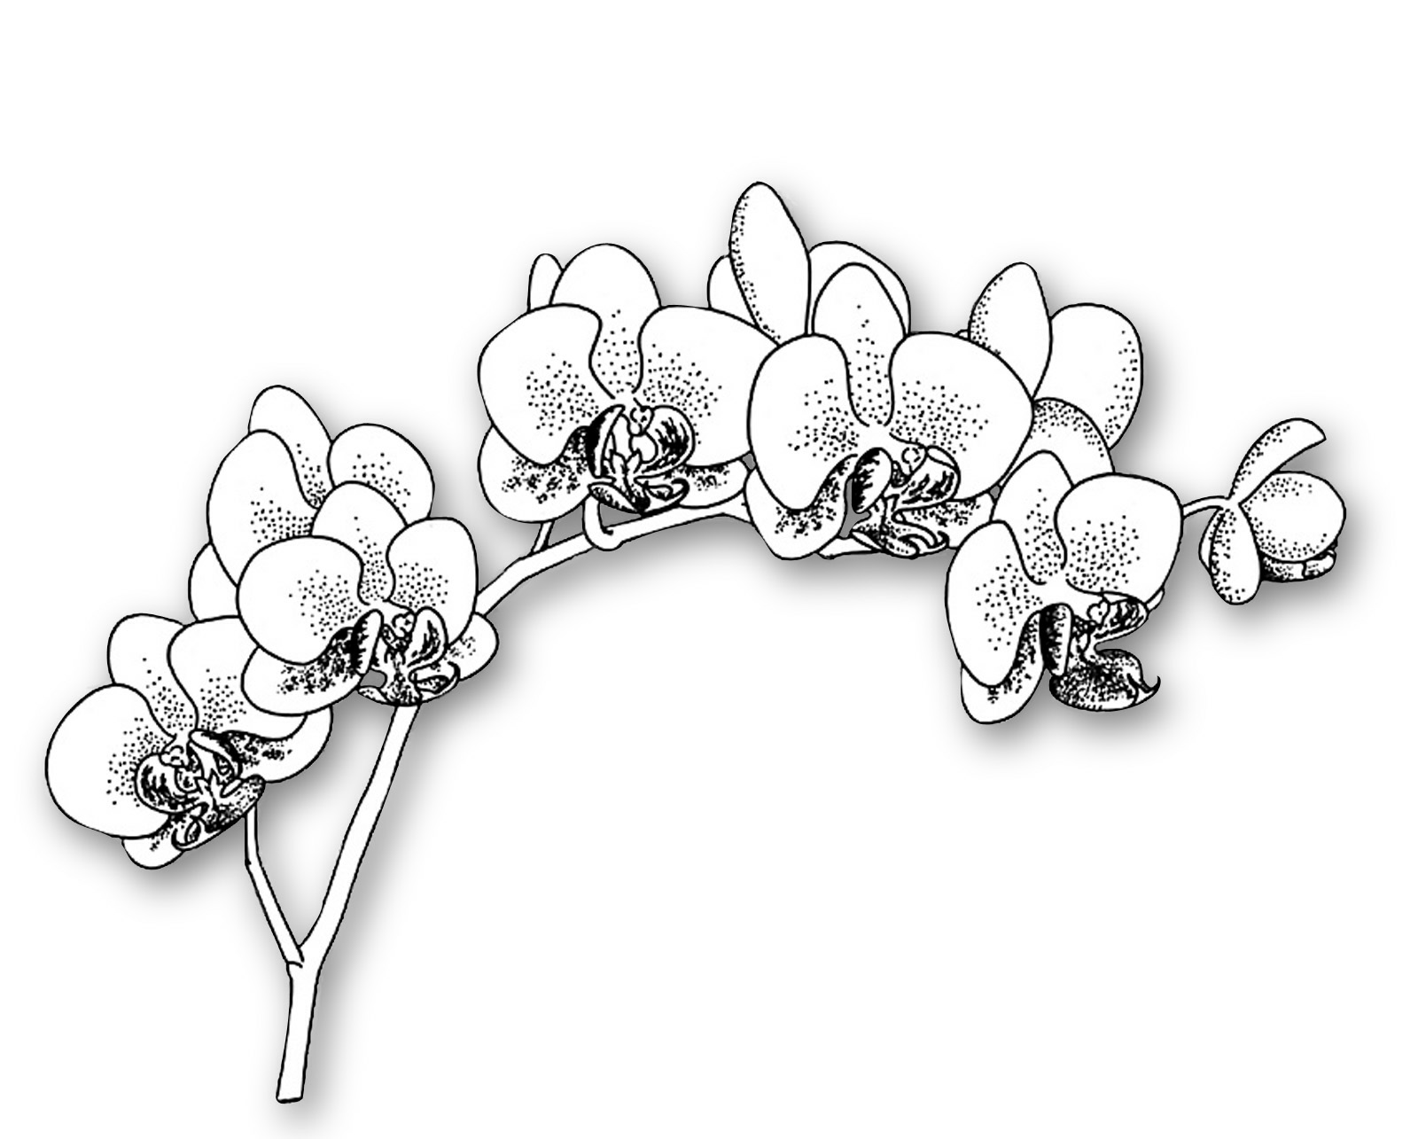

*What we do…*

* Bring together worldwide growers to share and to promote our passion for Phalaenopsis orchids.
* Published *Phalaenopsis, The Genus in Pictures*; available to IPA members at a discount.
* Publish the *Phalaenopsis Journal*, a quarterly digital magazine featuring color photography including articles on new lines of breeding, cultural techniques and other subjects of interest to Phalaenopsis growers.
* Stage an annual symposium at various world locations filled with workshops and lectures from the world’s foremost growers and hybridizers.
* Provide financial support of Phalaenopsis species collection at Atlanta Botanical Gardens.
* Sponsor Phalaenopsis related projects such as the revision of the genus, *Phaleanopsis: A Monograph* by Dr. Eric A. Christenson.

*Please visit our website:*

[*www.phal.org*](http://www.phal.org)

Lynn Fuller, Membership Secretary

1401 Pennsylvania Ave, # 1604

Wilmington, DE 19806 USA

mlfuller@comcast.net

302-594-0765